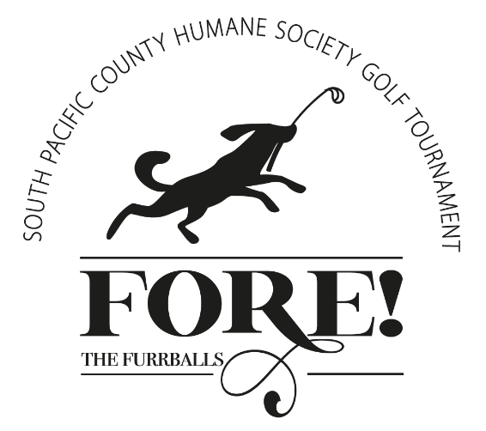
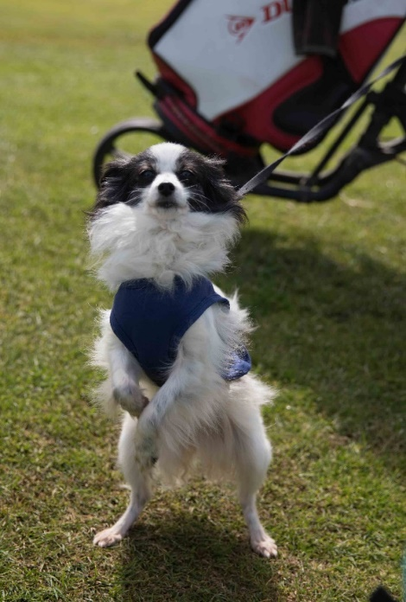
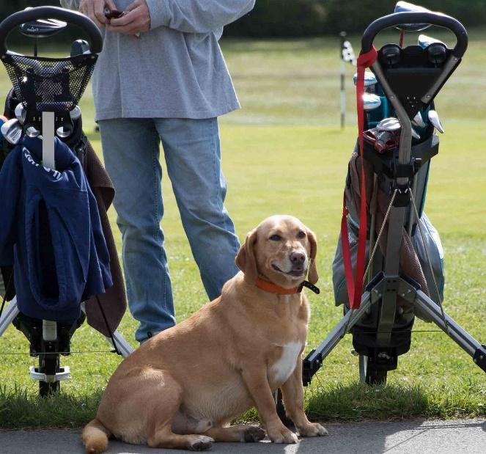
$65 per player
EARLY BIRDS $55
through July 8
Register Online:
auctria.events/FURRBALLS

Enjoy a complete program of special events, 9 holes of golf, including box lunch, door prizes and an awards ceremony.
To reserve and pay for a cart, contact Peninsula Golf Course – 360-642-4653
Prizes for:
Winning Teams
Longest Drive
Closest to Pin
Straightest Drive
Hole-In-One
Exciting contests for golfers and their supporters:

- Shotgun Putting Contest
- Multiple Prize Raffle
Register Online:
auctria.events/FURRBALLS
Peninsula Golf Course
9604 Pacific Way
Long Beach, WA 98631
360-642-4653

This year’s events will be held on Sunday July 14 at the well-manicured Peninsula Goff Course in Long Beach Washington.
Registration will be online with check-in-beginning at 9 am, and tee-off at 10 am.
The cost for this event is only $55 for early birds registering through July 8th and $65 after. This price includes 9 holes of golf, box lunch, awards, and the opportunity to participate in exciting bonus games. Contact the Peninsula Golf Course to reserve and pay for a cart.
There will be an awards presentation immediately following box lunch provided by the Cove Restaurant presents.
To help us properly plan for this event. Please per-register at auctria.events/FURRBALLS.
Humorous, natty and team golf attire is encouraged.

Humorous

Golf with your dog at the FORE! The Furrballs Golf Tournament!
9 Hole – 2 Person Teams

FORE! The Furrballs Golf Tournament

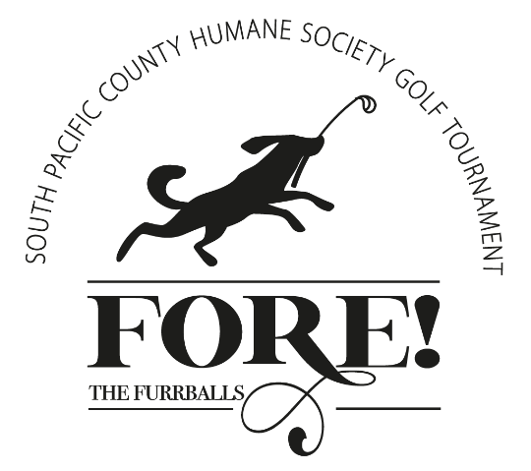

SPONSOR LEVEL | Hole in  One | Great  Dane | Lab | Sheltie | Pug | Puppy | Prize  Persian
Investment in the Pets: | $300 | $250 | $200 | $100 | $50 | $25 | Items
Tournament Play Entry | 2  Golfers | 2  Golfers | 1  Golfers
Mulligans. 3 of ‘em | 2 sets | 2 sets | 1 set
Sponsor Sign with your name and logo placed on the course (when conﬁrmed by July 7th)
Acknowledgment of your gift during the Opening Announcements
Acknowledgment of your gift on
SPCHS Furrballs event website
Acknowledgment of your gift on
SPCHS Facebook page
Your logo on the home page
Of SPCHS website for one year
Post-event acknowledgment in the Chinook Observer shelter report

Questions? Sandy Clancy | sandy@beachpets.com | 602-670-5770

Yes! I want to help homeless pets!

1. PLEASE PRINT
Name | Business Name (if applicable)
Phone | Email
www

2. Choose your investment in the shelter’s pets:

Hole in One | Great Dane | Lab | Sheltie | Pug | Puppy | *Prize Persian
❏ $300 | ❏ $250 | ❏ $200 | ❏ $100 | ❏ $50 | ❏ $25 | ❏ I will donate a prize for the raffle.

- Prize Persian value _$__________
- Depending on the number of prizes donated, your Prize Persian may be used for future fundraising events.

- You can select your sponsorship level and pay with a credit card at auctria.events/FURRBALLS.

OR

Make your check payable to SPCHS
And mail, with this sheet, to:

SPCHS Golf Tournament
PO Box 101
Long Beach, WA 98631
OR with this sheet deliver to:

SPCHS Shelter
330 Second St NE - Long Beach
Open 11 am – 3 pm, Tues.–Sat.

4. Send your digital art to: sandy@beachpets.com

More Info: Sandy Clancy | sandy@beachpets.com | 602-670-5770

