LOST CAT
REWARD
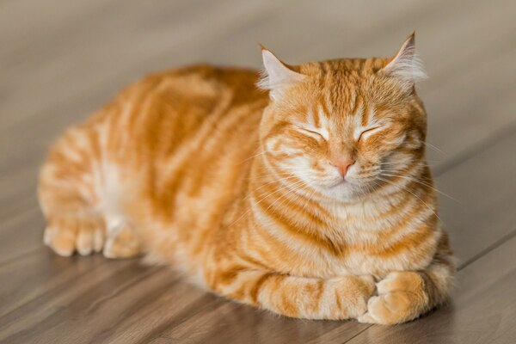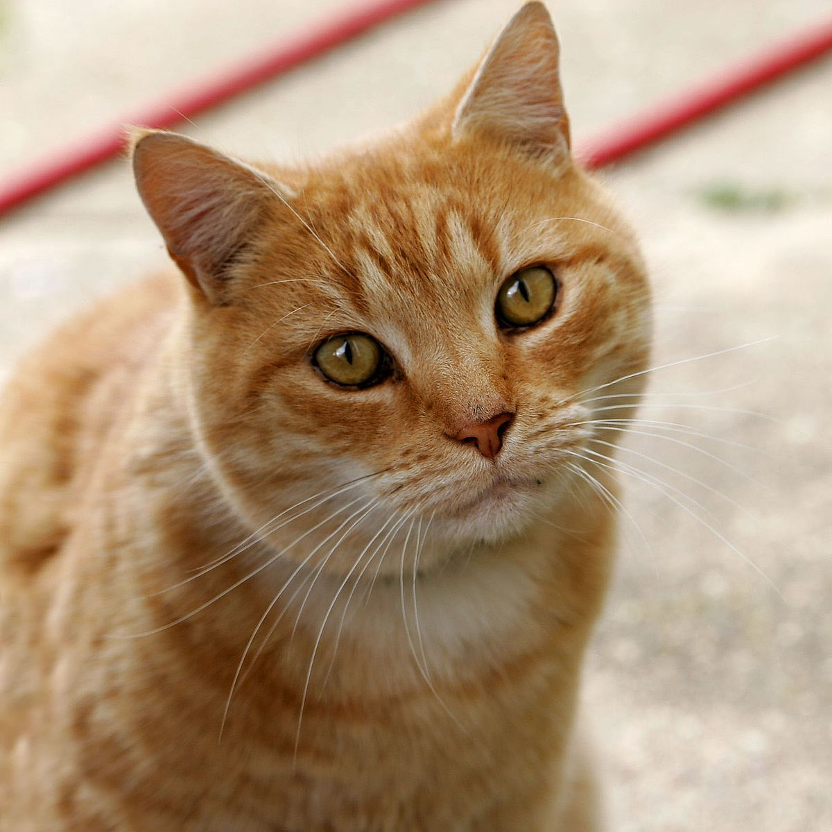
Replace with one or two of your pet: show face and body, then erase this text.
"SUNKIST" the Orange Tabby
Identifying marks: Gold eyes, extra toe on her front right paw and huge back paws. Answers to her name. Chica needs medicine right away!
Last seen: Corner of 2nd NE & Washington, Long Beach, WA | Jun 12 2020 | 8:00 a.m.
Contact (360) 555-1212
Email: ChicasFamily@gmail.com

